**Introduction to vim**

vi or vim is a popular editor used in Linux systems. It can seem a bit daunting to the novice, but it is a very powerful editor and is another useful skill to have in your toolkit. Most Linux system administrators look down on anyone who cannot operate adequately in vi.

On most modern systems vi or vim can be used interchangeably. They both execute the same program. Files are edited in vim by typing  
 **vim filename.ext<ENTER>** in the bash shell.

vim has three operating modes.

* Normal Mode which is entered as soon as a file is opened.
* CMD mode which is accessed from Normal Mode by typing **<ESC>:** followed by a command.
* Insert mode which is accessed from Normal Mode by typing **i**.
  + There are other versions of Insert mode, but we will stick with Insert Normal Mode for now.

vim Cheat sheet:

**Note:** <ESC> is the Escape key in the top left corner of your keyboard.

* **<ESC>:** -- enters command mode.
* **<ESC>:q!<ENTER>**  -- force quit and don't save
* **<ESC>:w<ENTER>** -- save
* **<ESC>:q<ENTER>** -- quit, only works if file has *not* been modified
* **<ESC>:wq<ENTER>** -- save and exit
* **i** -- enters insert mode so you can edit text
  + This command is performed when in normal mode
* **dd**-- deletes an entire line
  + This command is performed when in normal mode
* **<ESC>:e /path/to/filename.ext<ENTER>** -- edits another file called filename.ext at the specified location. If the file is in the current working directory that you launch vim from, only filename.ext is needed.

1. Lets begin with setting up our vim configuration file with a few customizations.
   1. **vim ~/.vimrc<ENTER>**
   2. Type **i** to enter insert mode

Then copy the following and paste it into your terminal window. The following will map the F5 key to execute a python script without having to exit vim. It also sets up syntax highlighting, color schemes, folding, and makes some modifications to tabs to meet PEP8 standards.

:map <F5> :!python %<CR>

:map <F2> :w<CR>

let python_highlight_all=1

syntax on

colorscheme desert

" Enable folding

set foldmethod=indent

set foldcolumn=2

set foldlevel=99

set nu

" Enable folding with the spacebar

nnoremap <space> za

" Setup tabbing to PEP8 standards

set expandtab

set autoindent

set tabstop=4

set softtabstop=4

set shiftwidth=4

1. Now save and exit by typing **<ESC>:wq<ENTER>**
2. Type more ~/.vimrc to show that you successfully saved the vim configuration file with the above settings. Take a screenshot.
   1. Insert Screenshot here:
   2. 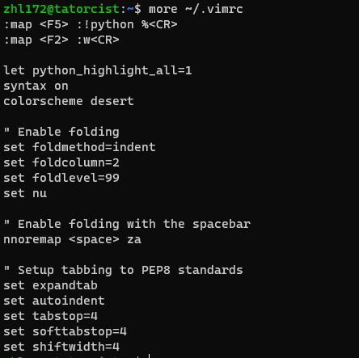
3. HINT: Consult the Python Vitual Environment lab if you cannot remember how to perform the next 5 steps.
4. Activate your Python Virtual Environment
   1. What command did you type to do so?: source ~/py3/bin/activate
5. Next navigate to the root of your home directory.
   1. What command did you type to do so?: cd ~/
6. Produce a directory listing and check to see if a directory named Documents exists.
   1. What command did you type to do so?: ls
7. If Documents does not exist, create it.
   1. What command did you type to do so?: mkdir Documents
8. Now navigate into your Documents directory.
   1. What command did you type to do so?: cd ~/Documents/
9. Next open a new file called helloworld.py in vim.
   1. What command did you type to do so?: vim helloworld.py
10. Switch into Insert mode.
    1. What command did you type to do so?: i
11. On Line 1 type: # A simple helloworld python script
12. On Line 2 type: print('Hello World!')
13. Save the file but do not exit (Consult the cheat sheet on page 1)
    1. What command did you type to do so?: :w
14. Execute the file by pressing F5 and take a screenshot. You should see Hello World! Typed out on your screen.
    1. Insert screenshot here:

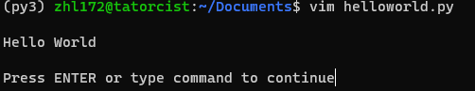

1. Exit vim
   1. What command did you type to do so?: :q
2. Finally execute your script from the bash shell by typing   
   **python helloworld.py**
   1. Take a screenshot and paste it here:

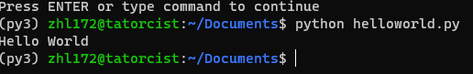

1. Now that we have setup our development environment, we can start learning about Python.